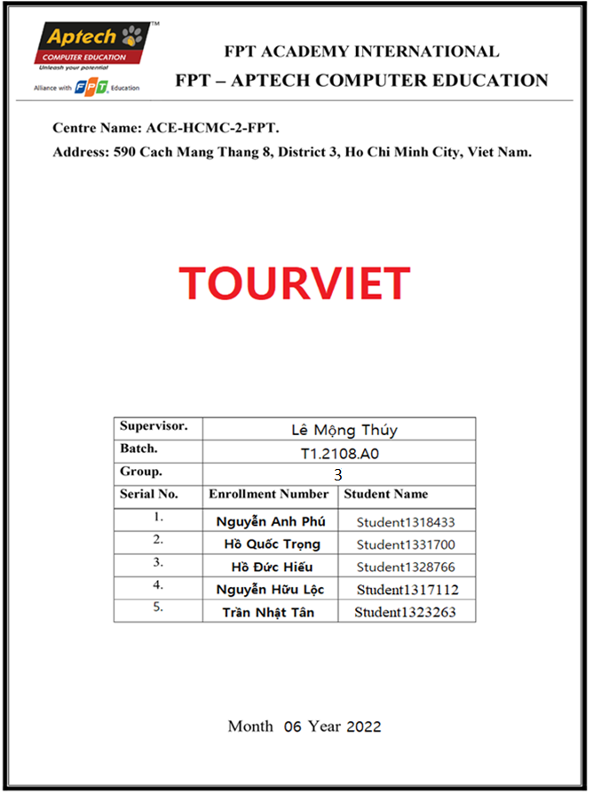

**CONTENT**

REVIEW 1 3

ACKNOWLEDGE 3

INTRODUCTION 3

PROBLEM DEFINITION 4

CUSTOMER'S REQUIREMENTS SPECIFICATIONS (CRS) 5

FUNCTION DIAGRAM 10

TASK SHEET REVIEW 1 11

REVIEW 2 13

DATA FLOW DIAGRAM (DFD) 13

ENTITY RELATIONSHIP DIAGRAM (ERD) 16

USECASE………………………………………………………………………………………………………………………………………………………17

ENTITY PROPERTIES………………………………………………………………………………………………………………………………………18

SITEMAP (PHP)……………………………………………………………………………………………………………………………………………….20

TASK SHEET REVIEW 2 22

REVIEW 3 23

WIRFRAME…………………………………………………………………………………………………………………………………………………24

SCREENSHOT……………………………………………………………………………………….……………………………………………………….37

TASK SHEET REVIEW 3…………………………………………………………………………………………………………………………………46

**REVIEW 1**

## ACKNOWLEDGE

Our group would like to devote this chapter to express our sincere appreciation to all those who offered us valuable assistance during in carrying out this Project.

Firstly, we owe a debt of gratitude to our dedicated instructor, MS. Le Mong Thuy, whose suggestions and encouragement helped us to overcome not only technological challenges but also psychological tension. Without him, our work could not complete successfully.

Secondly, we highly appreciate the Project Team at the Head Office, which has provided us an excellent opportunity to apply what we learned into practice. We are certain that the experiences we gained from this project will facilitate our future career greatly.

Thirdly, we would also like to express my gratitude to all the staff members of my center for not only providing me with the opportunity to work with them on this project, but also for their support and encouragement throughout the process.

Finally yet importantly, we wish to say a personal thank you to all our dear classmates and team members who are always willing to support us openly and enthusiastically.

**INTRODUCTION**

Tour Viet is a web application that allows users to book tours, our website is full of hot places and convenient services to give users an extremely memorable experience, booking similar tours such as booking air tickets or ordering clothes, users choose any tour to add to the tour list, then enter the necessary personal information such as email, phone number, date and time and make payment.

This is the place for customers who don't have much time to learn about the tour or they are simply far from the booking center

**PROBLEM DEFINITION**

1. **Topic Requirement**

User can:

User can search tour.

The site allows users to book tours.

Allows to see detailed information about the tour.

Users can login and register.

User can send feedback.

Users can contact us.

User can view transaction history.

Admin can:

Manage booked tour information

Manage tour information

Manage feedback

Manage customer account

Manage transaction

1. **Current Status Problem**

*How is the tour going?*

*How is the quality and price of the tour?*

*Is the guide team as well as the service good?*

*How are promotions and discounts applied?*

Solutions

After analyzing the project specifications of Tour Viet, to fulfil customer’s requirements properly, we came to conclusion that in order to achieve the best result, we should deal with following queries:

* As you have seen, customers often have different questions about different types of products. That's why we solved that problem by leaving our contact phone number or messenger as default right on the home page and all other pages.
* That way we can respond to customer inquiries quickly and efficiently

**REQUIREMENTS SPECIFICATIONS**

1. **Input From The System:**

*administrators need to provide:*

* Information required in order creating account to access to the admin system.
* Tours and places are going to be shown on the website.
* Payment Method when booking tour.
* Information about tours and places
* ABC information ( phone number, company address, email …)

*Customers need to provide:*

* information to booking tour.
* Personal information to register.
* Feedback from user.
* Requests to the help center

1. **Output From The System:**

*administrators will be able to:*

* Manage (view, add, update, delete, hidden) price, promotion.
* Manage (view, update, delete, find, lock, unlock) customer account
* Manage (view, add, update, delete) news.
* Manage (view, add, update, find, delete) tour or place.
* Manage (view, update) feedback from user.
* Manage (view, update, find, delete) transactions.
* Manage (view, add, update, delete) information from website and company.

*Customer will be able to:*

* view tour, place when searching.
* View tour that they have chosen and checkout.
* View account information.
* View transaction history.

1. **Data Processing, Special Algorithms**

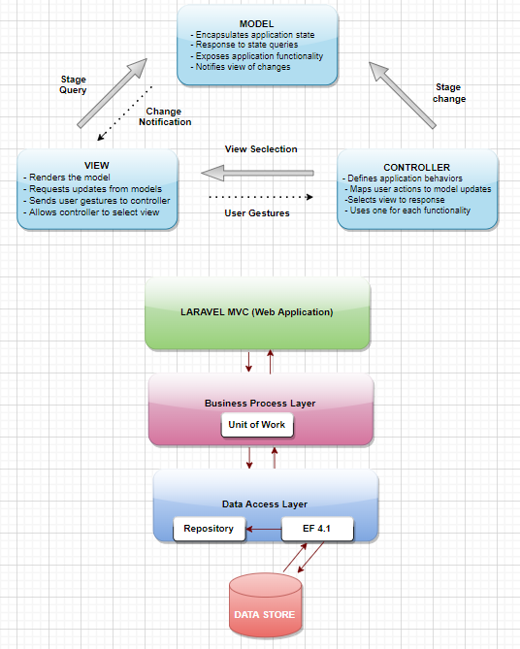

1. **Requirement From Hardware and Software**

Hardware:

Web Server

Processor Intel Core I3 or higher.

Memory 6 GB RAM or greater.

Modem/ADSL Internet access is required.

Client

Processor Intel Core I3 or higher.

Memory 6 GB RAM or greater.

Monitor Super VGA (1024x768) or higher resolution.

Modem/ADSL Internet access is required.

Software:

Server:

Web server: xampp, wampp …

Operation System: Window 7 or later.

Databases: MySQL.

PHP - Laravel framework

Browser Google Chrome version 35.

Client:

Operation System Window 7 or higher.

Browser Google Chrome , MS-Edge, Firefox

1. **Scope of work**

user can:

Search tour.

View tour.

View detail tour.

Book tour.

Contact.

Logged-in user :

Send feedback.

Get promotion.

View transaction history.

User must deposit 10% when booking tour.

User is not logged :

User is not logged must deposit 20% when booking tour

Admin can:

Manage tour.

Manage feedback.

Manage date start and end of tour

Manage account

Manage order

Manage transaction

**FUNCTION DIAGRAM**

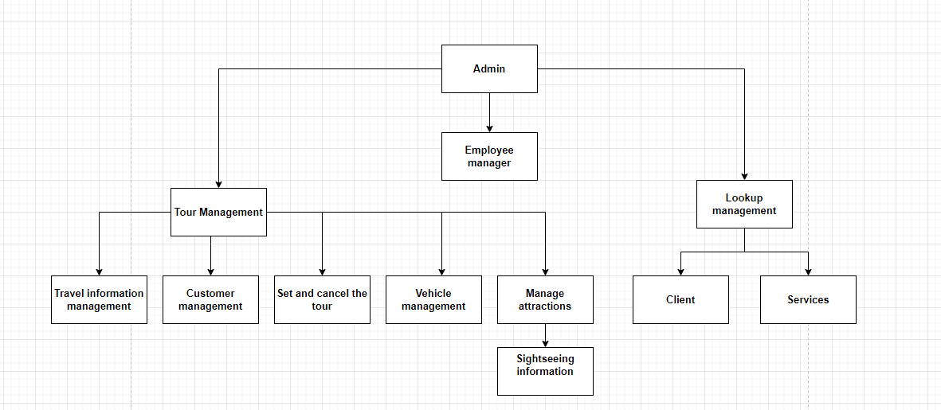

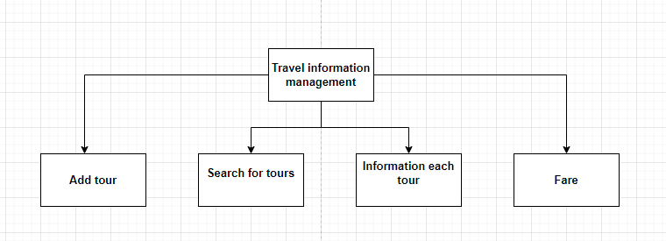

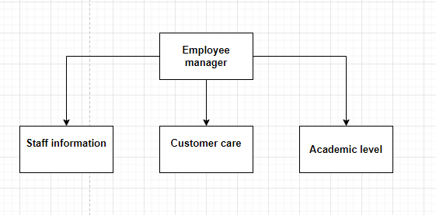

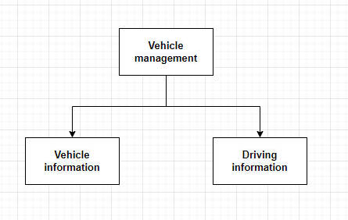

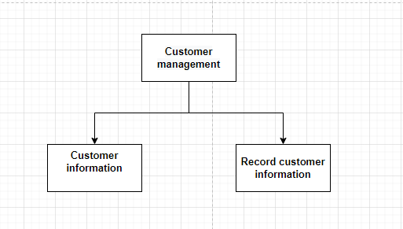

**TASK SHEET REVIEW 1**

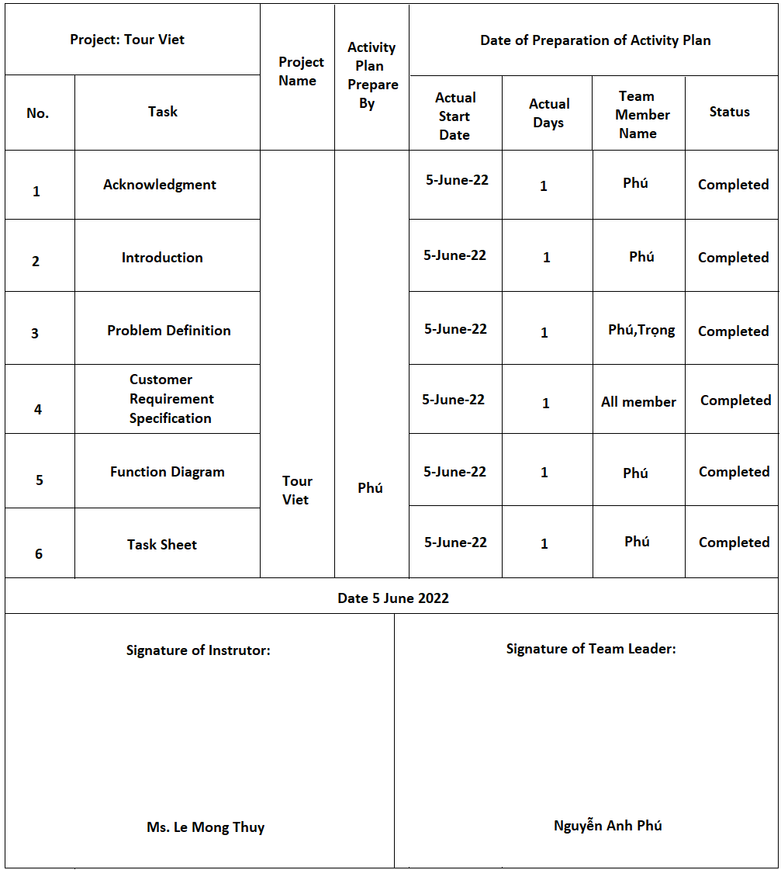

**REVIEW 2**

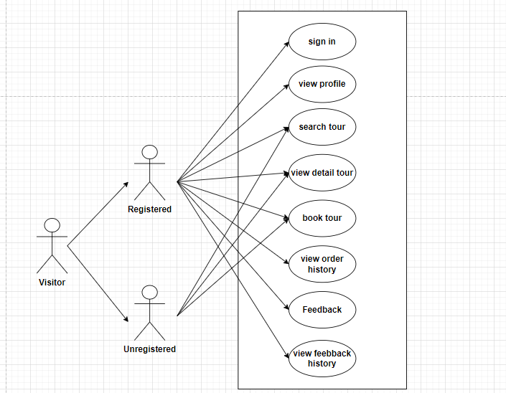**USECASE**

**DATA FLOW DIAGRAM (DFD)**

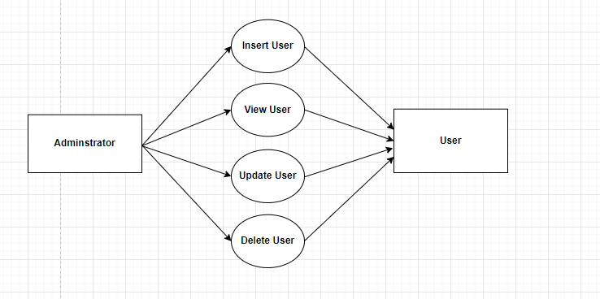

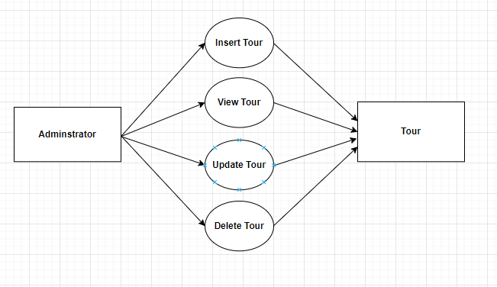

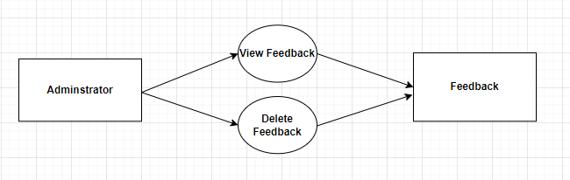

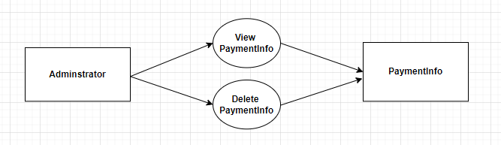

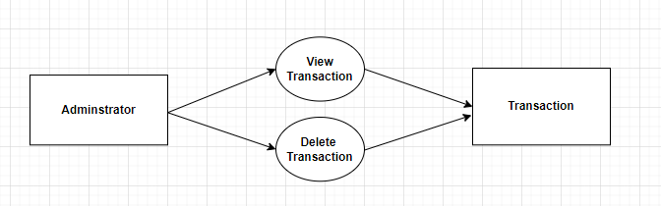

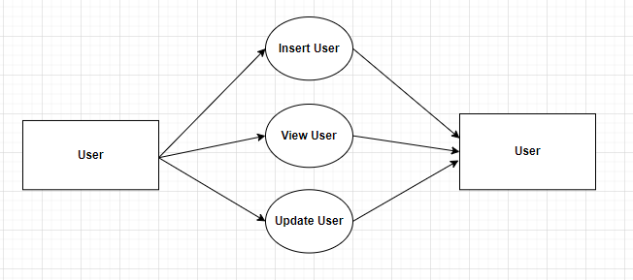

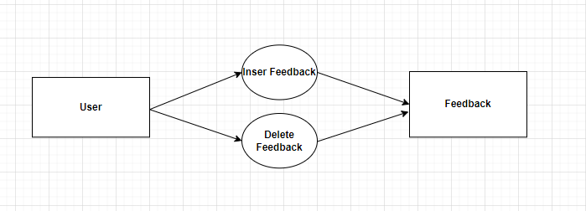

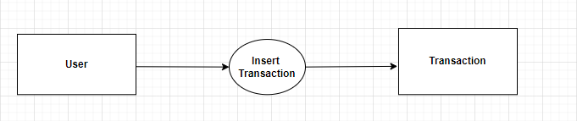

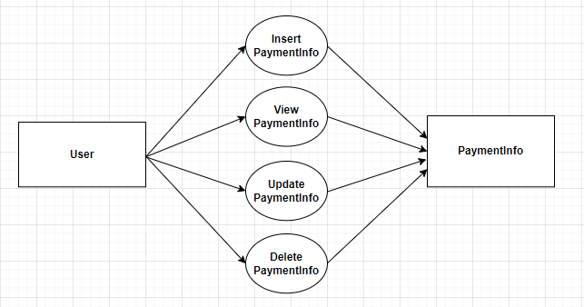

ENTITY PROPERTiES

USER

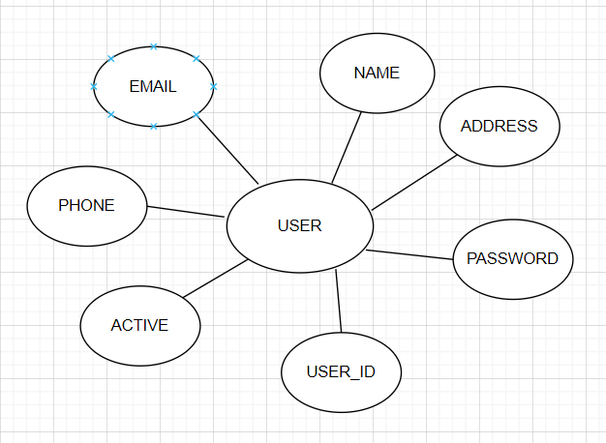

**ADMIN**

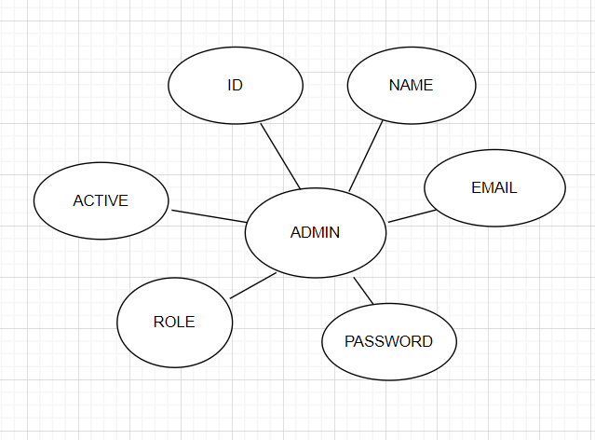

**ORDER**

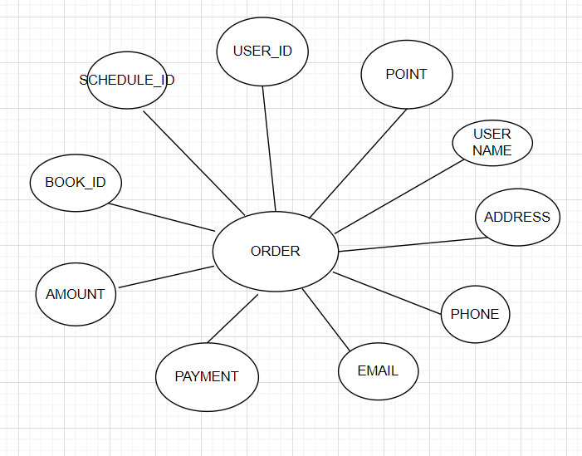

**TOUR**

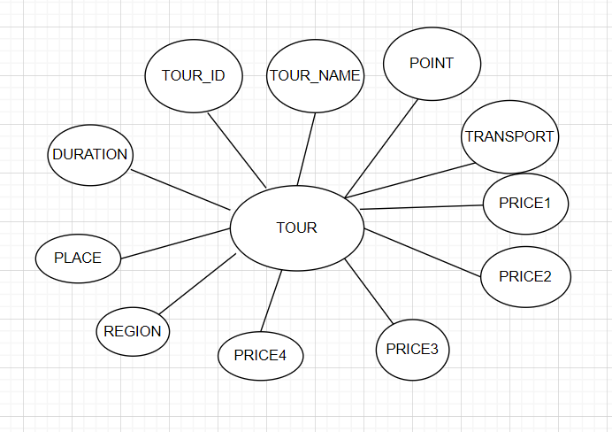

**CONTACT**

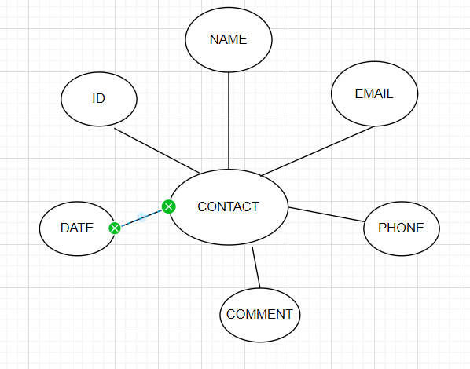

**FEEDBACK**

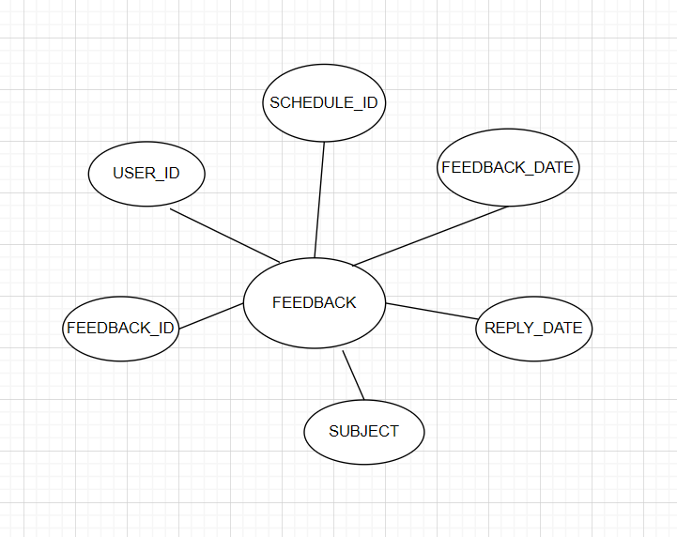

**LOCATION**

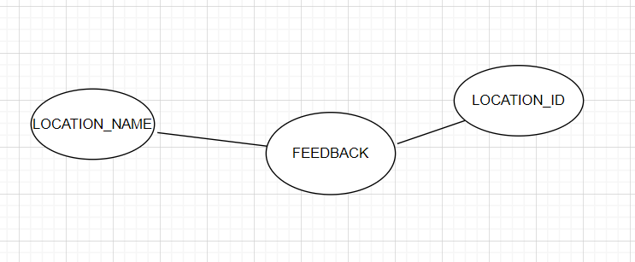

**NEWS**

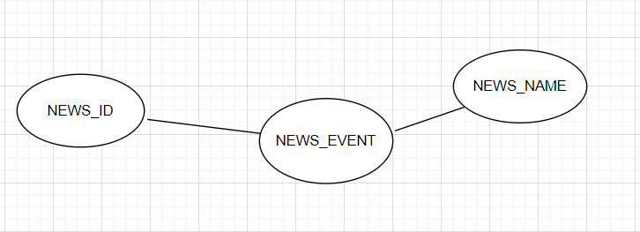

**SCHEDULE**

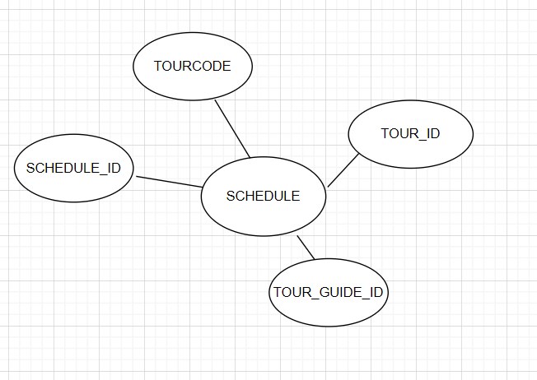

**TOUR GUIDE**

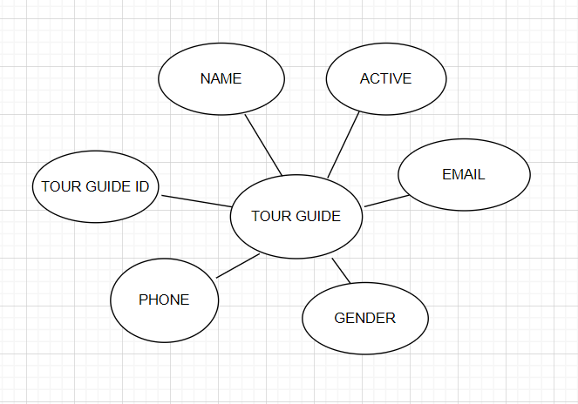

ENTITY RELATIONSHIP DIAGRAM (ERD)

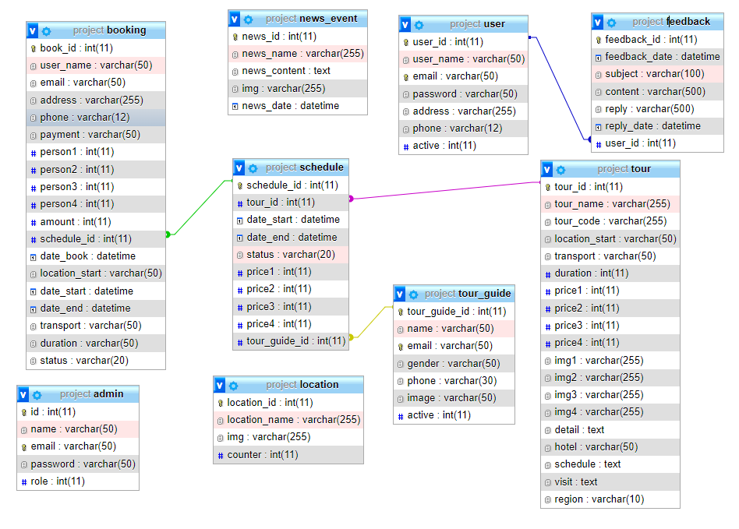

**SITEMAP**

1. **User**

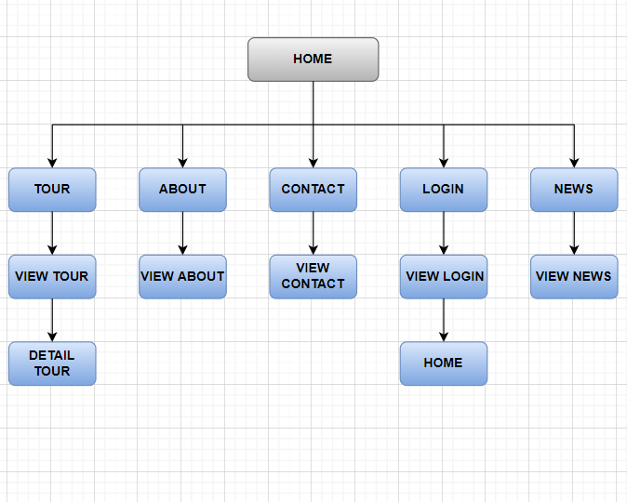

1. **Admin**

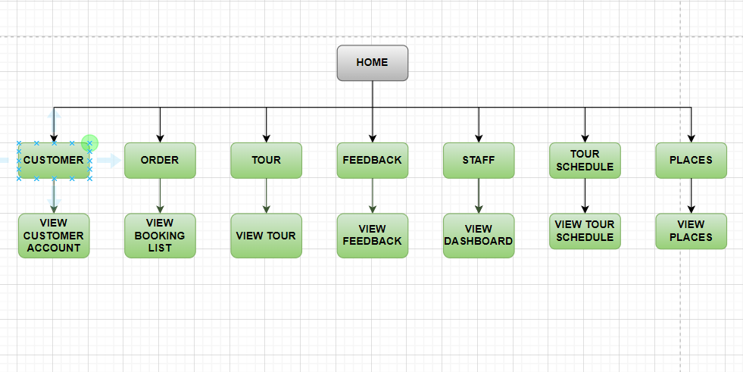

**TASK SHEET REVIEW 2**

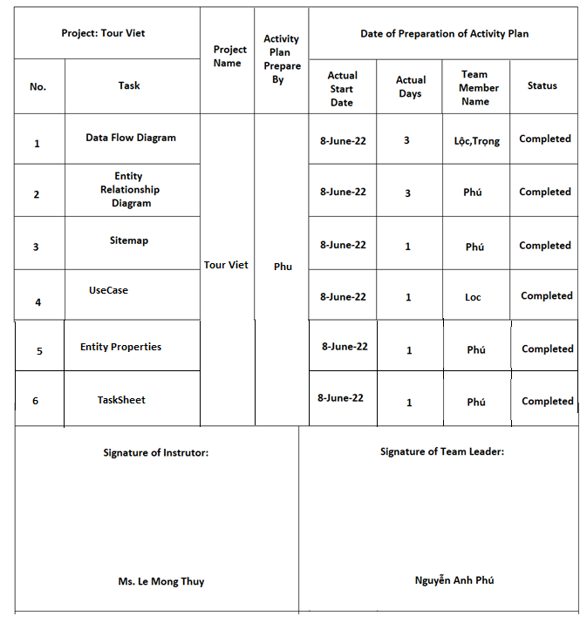

**REVIEW 3**

**WIREFRAME**

1. **User UI**

Home

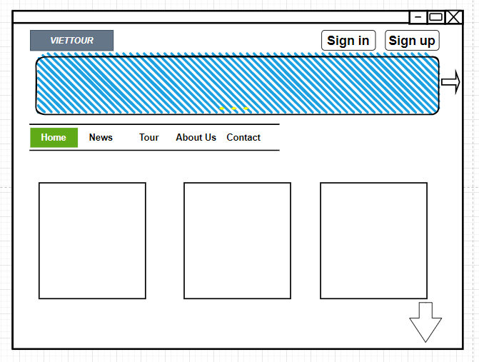

Tour

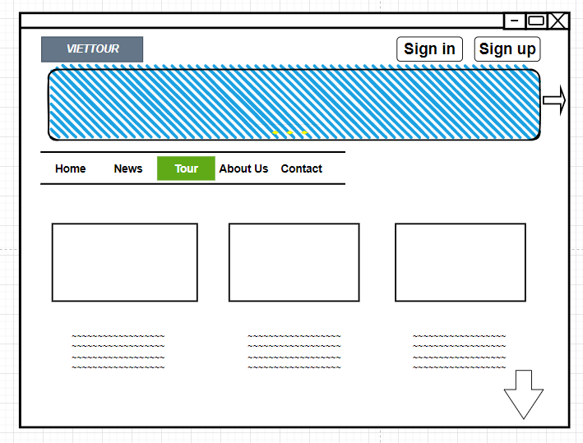

Detail Tour

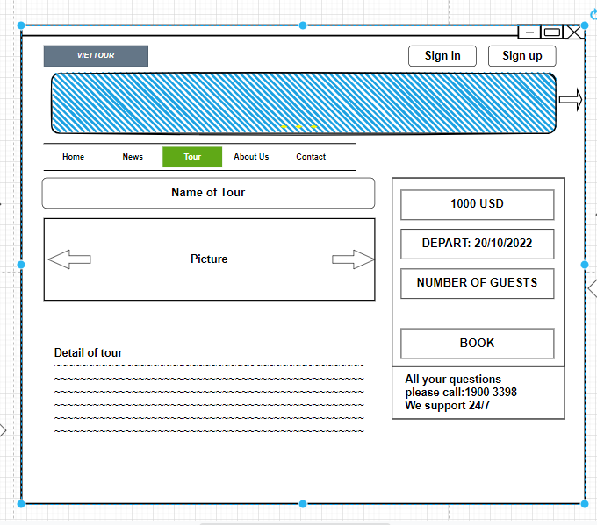

About

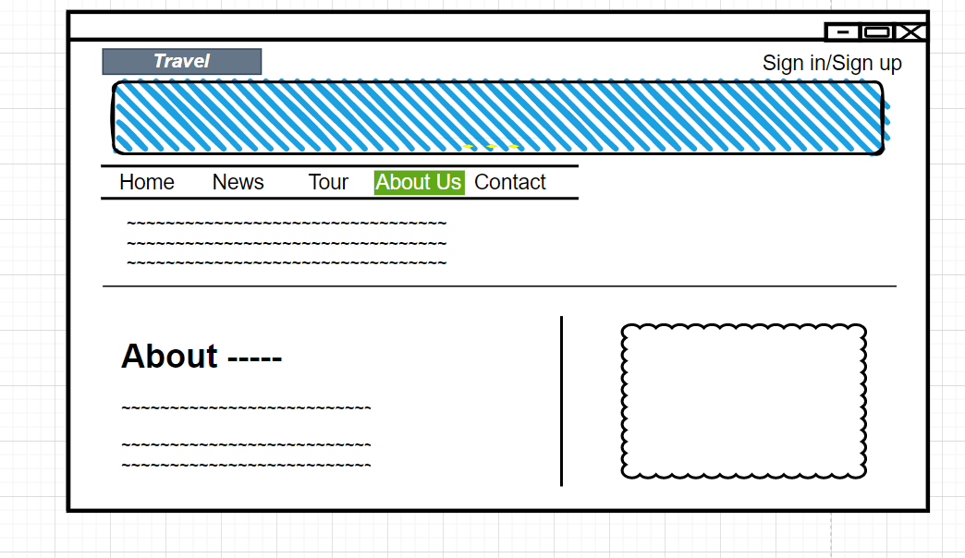

News

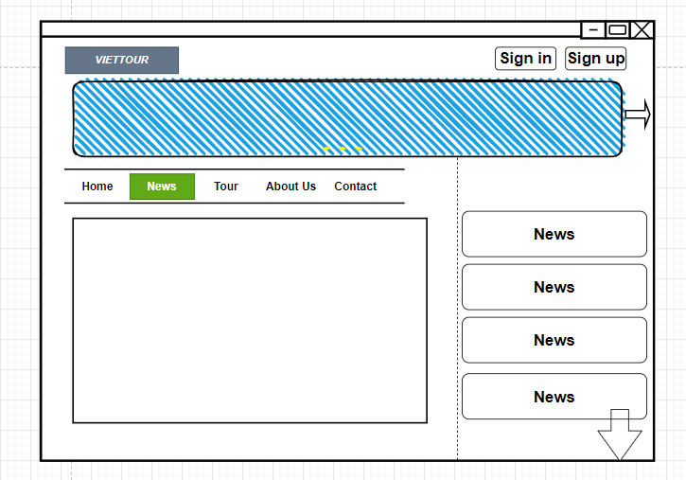

Contact

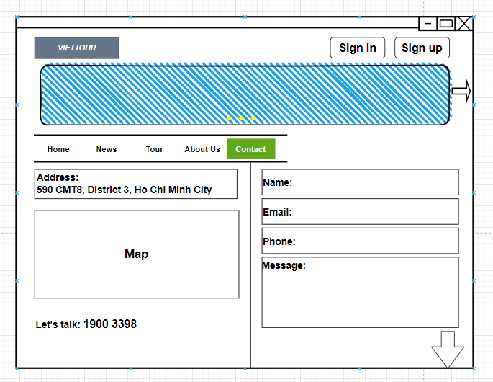

Sign in

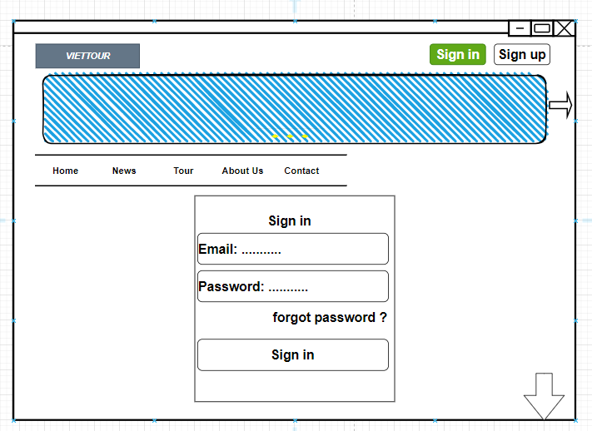

1. **Admin UI**

Dashboard

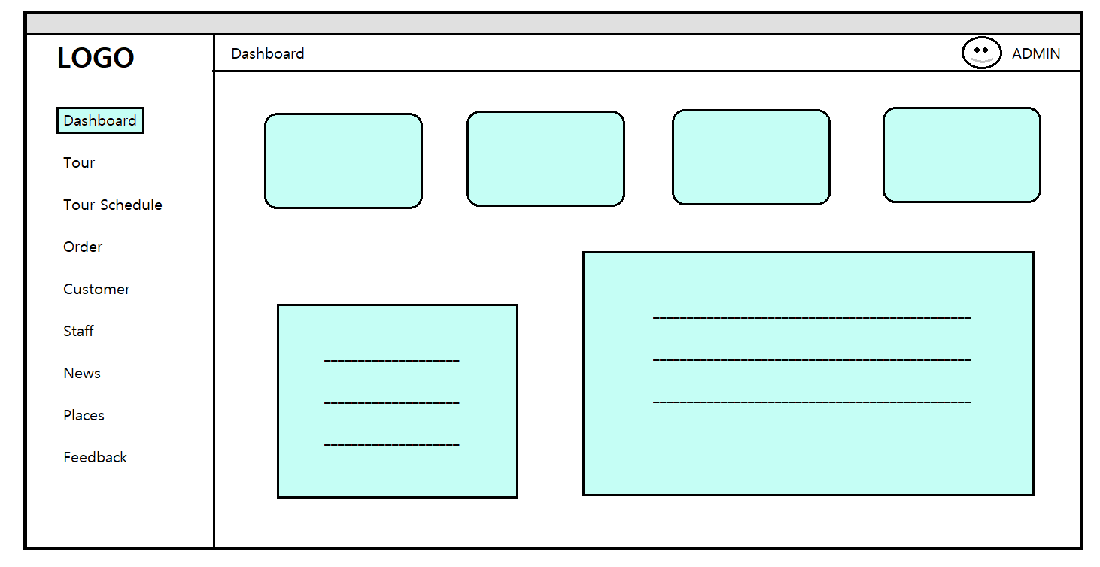

Tour

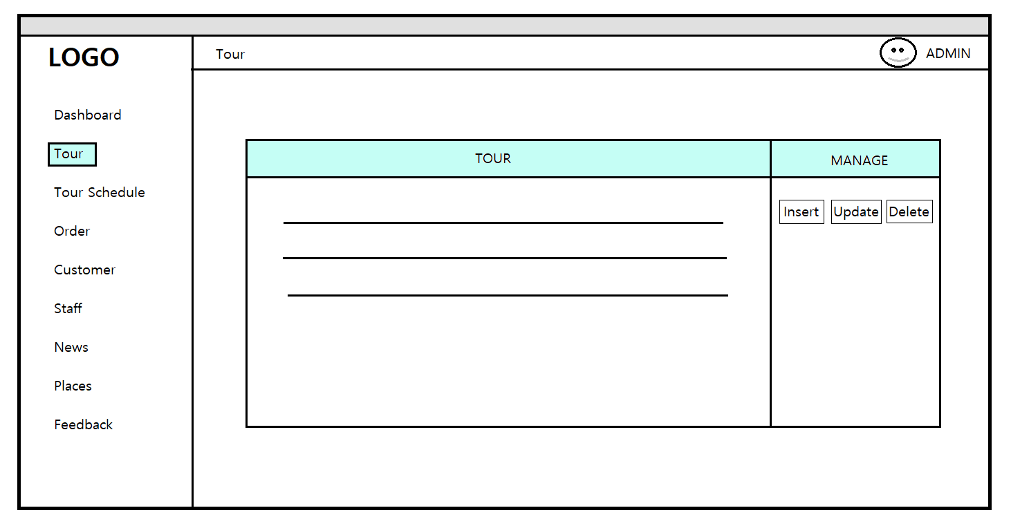

**SCREENSHOT**

Home

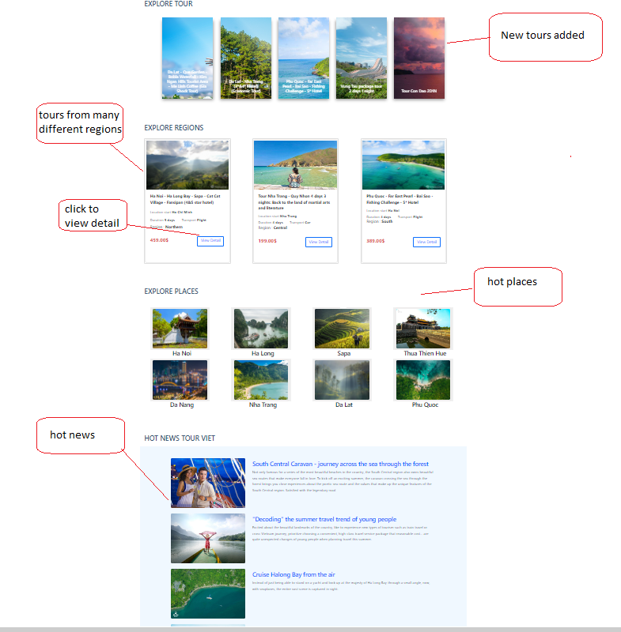

News

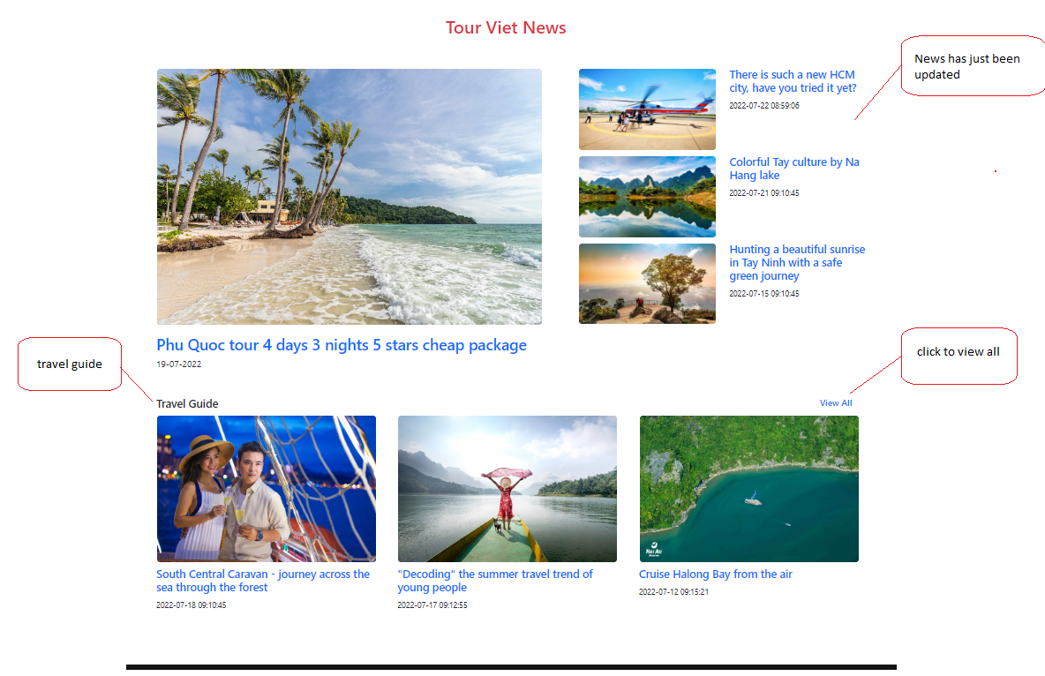

News Detail

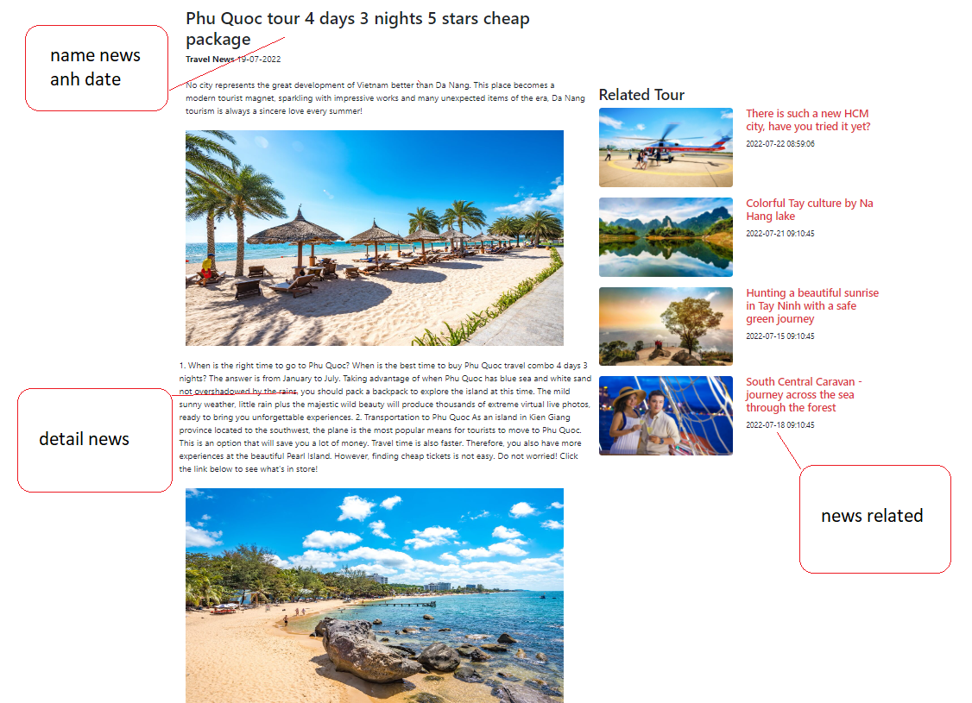

Tour

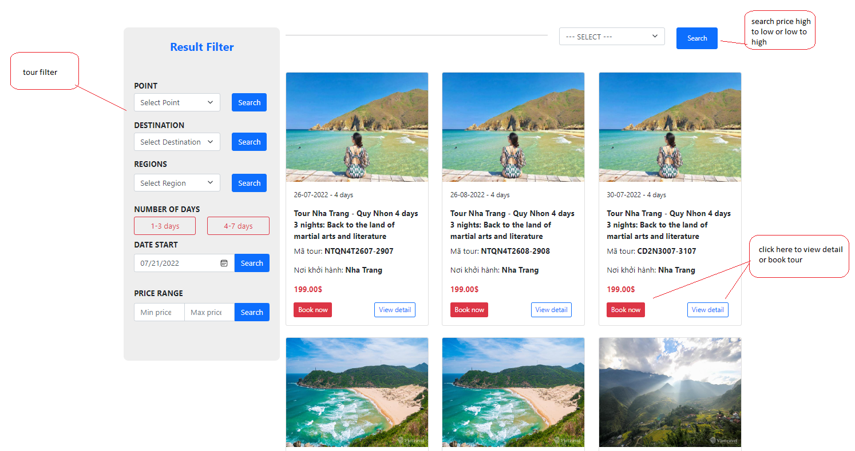

Detail Tour

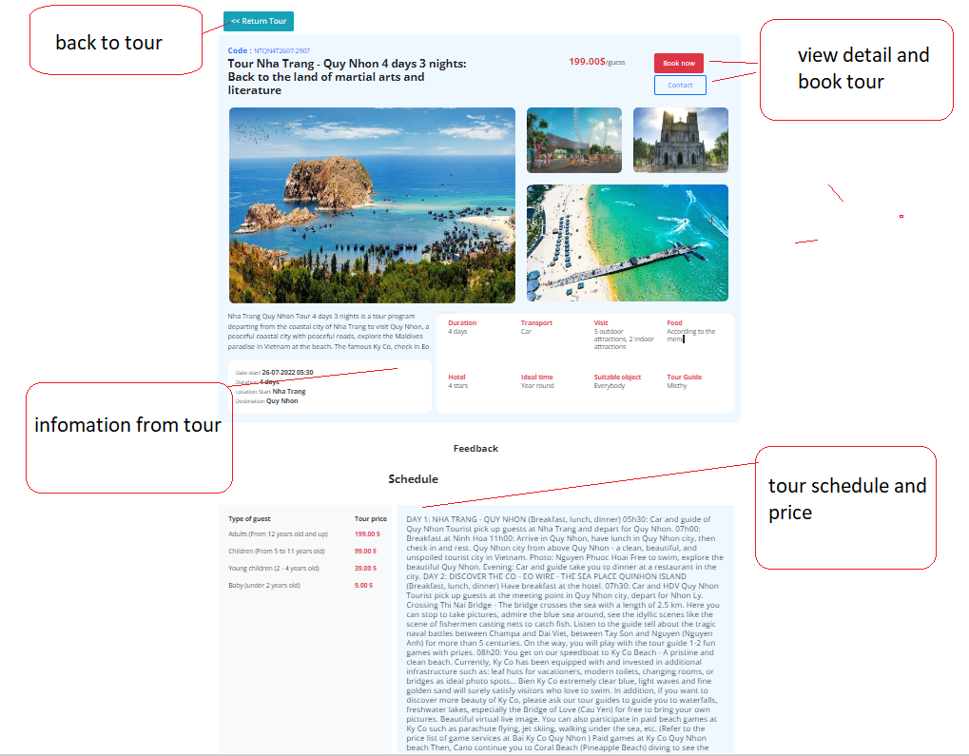

Payment

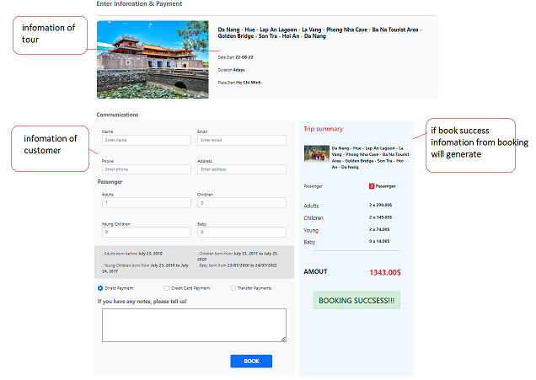

Contact

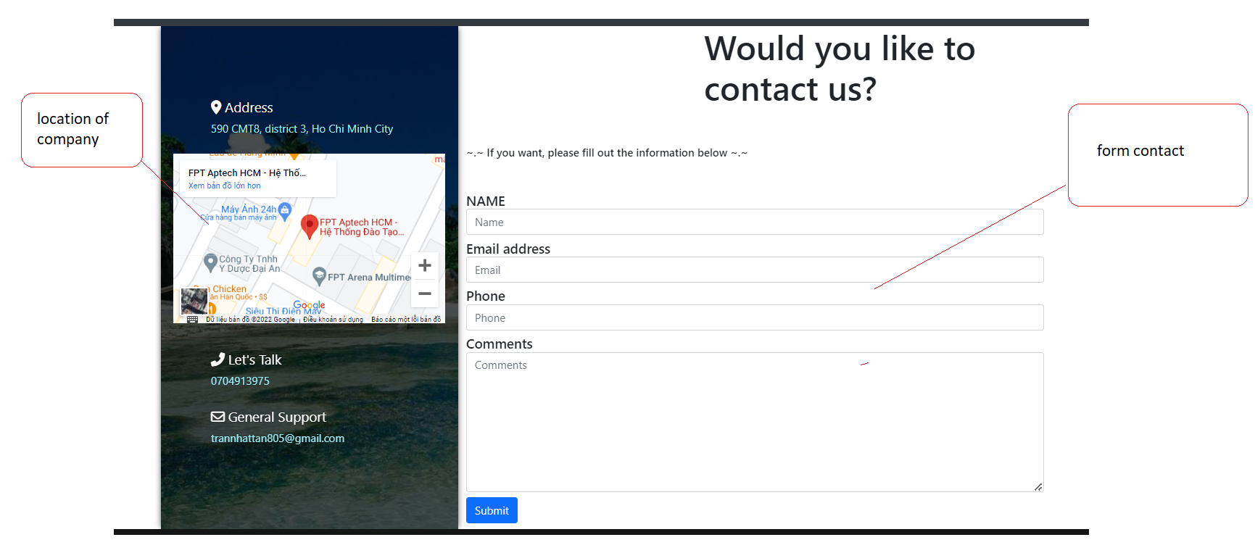

About Us

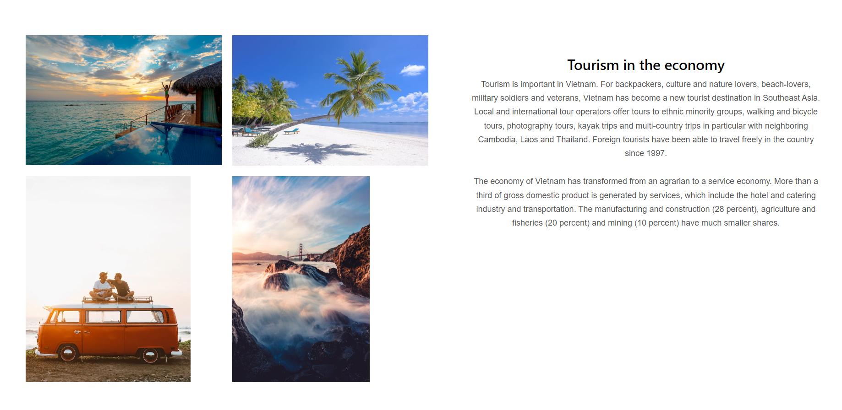

Admin Control

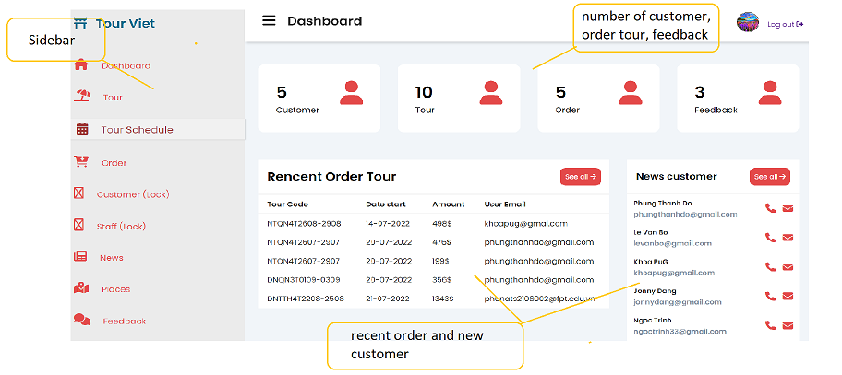

**TASK SHEET REVIEW 3**

